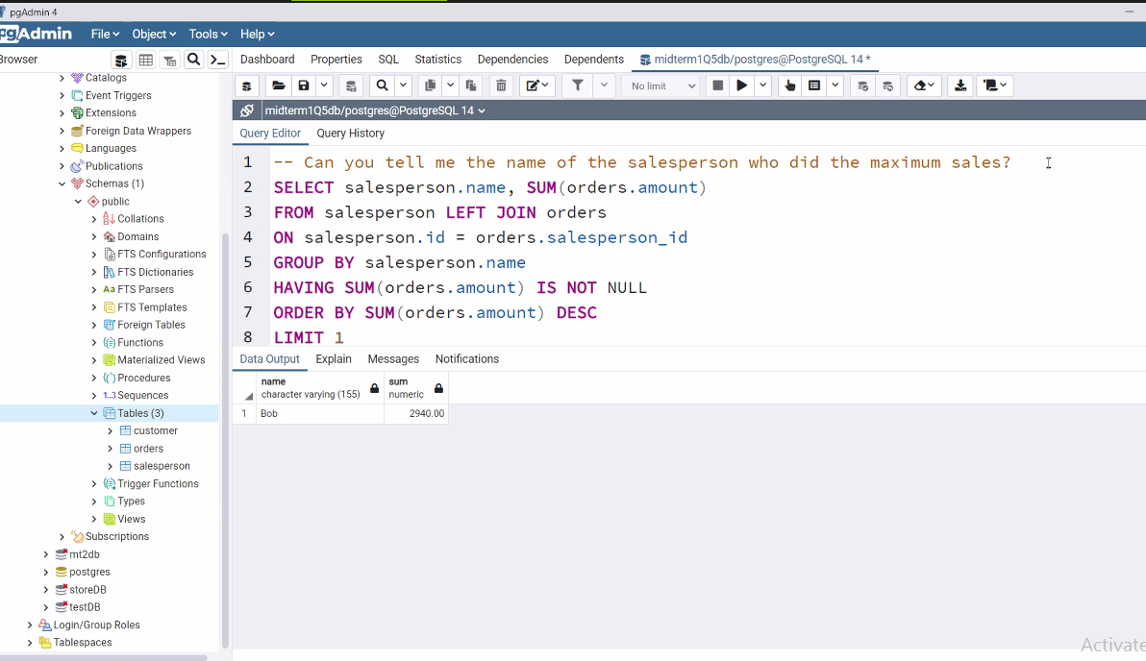

SELECT

FROM

WHERE

GROUP BY

HAVING

ORDER BY

OFFSET

LIMIT